

**AISHE CODE – C42105 Pun Code - CAAN017900 College Code 0731**



**6.2.2:** ***Institution implements e-governance in its operations***

1. ***Administration***
2. ***Finance and Accounts***
3. ***Student Admission and Support***
4. ***Examination***

*A.* ***All of the above***

*B. 3 of the above*

*C. 2 of the above*

*D. 1 of the above*

*E. None of the above*

**Our College website**

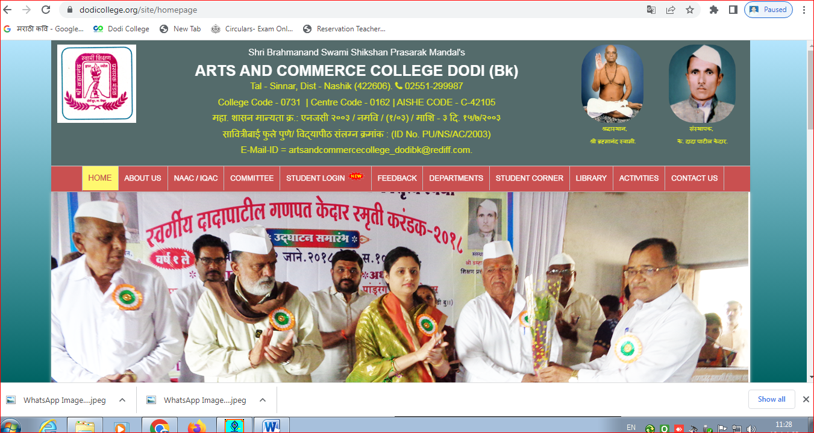

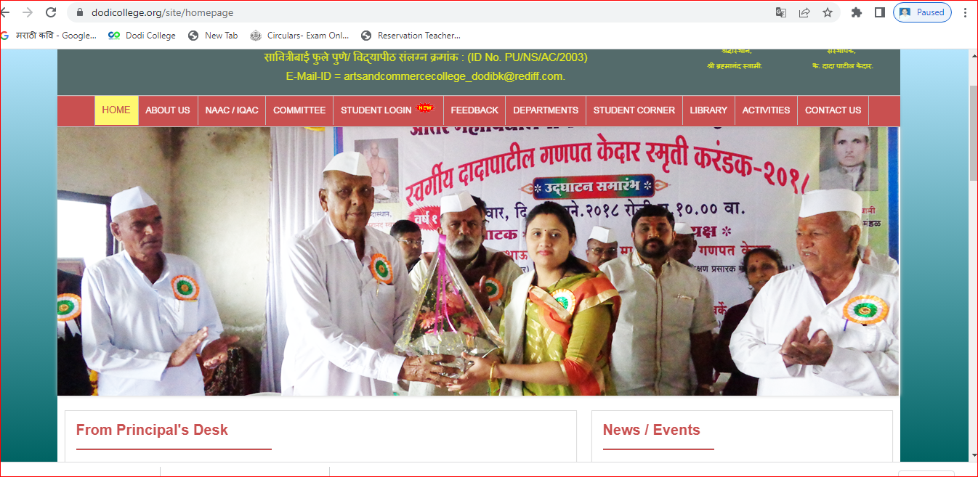

**ADMINISTRATION** 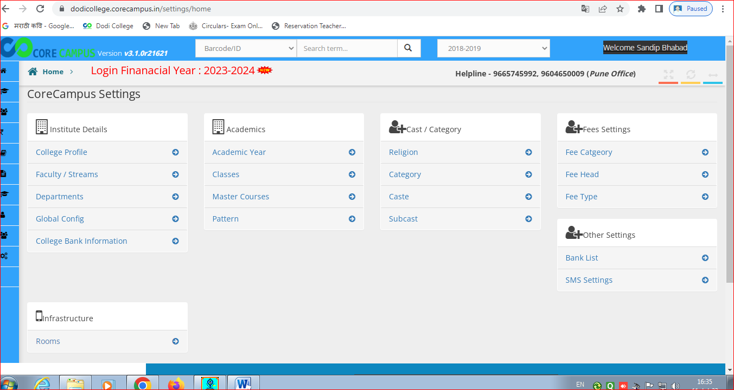

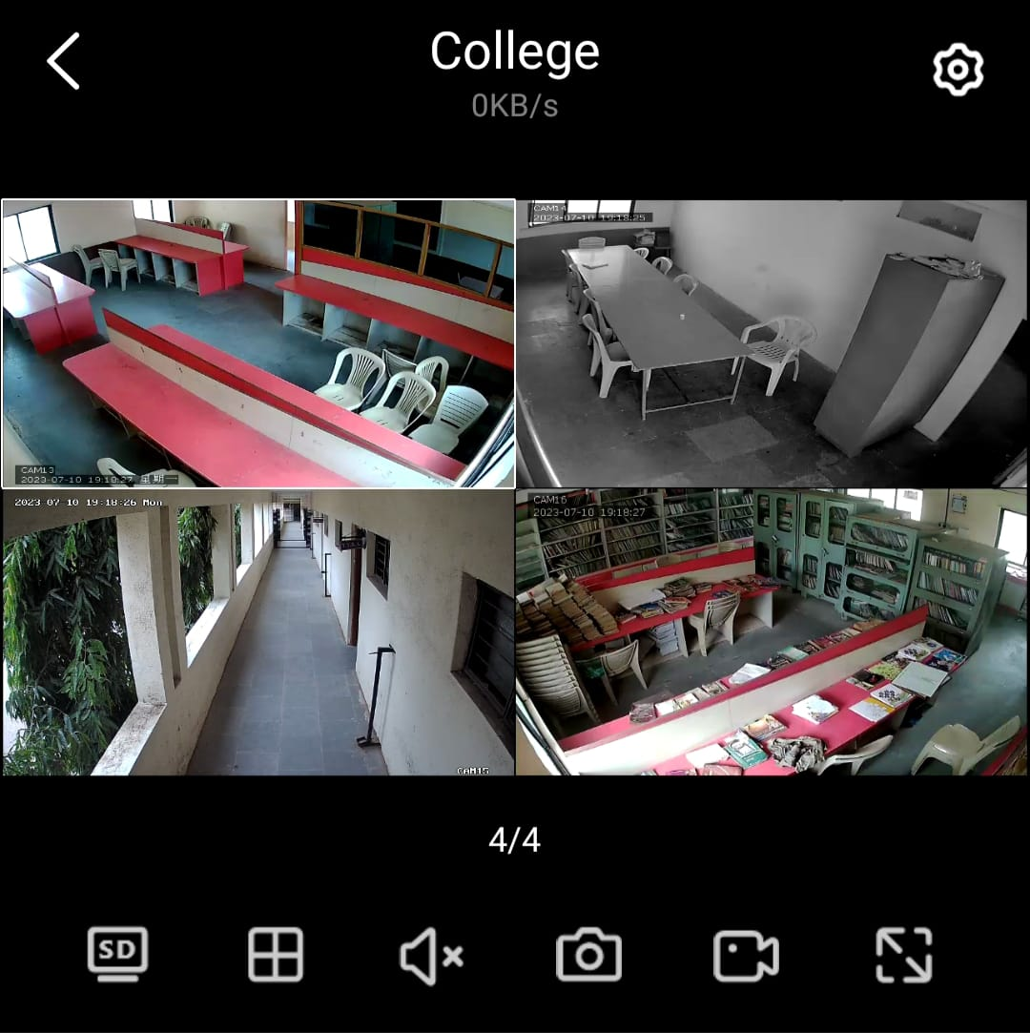

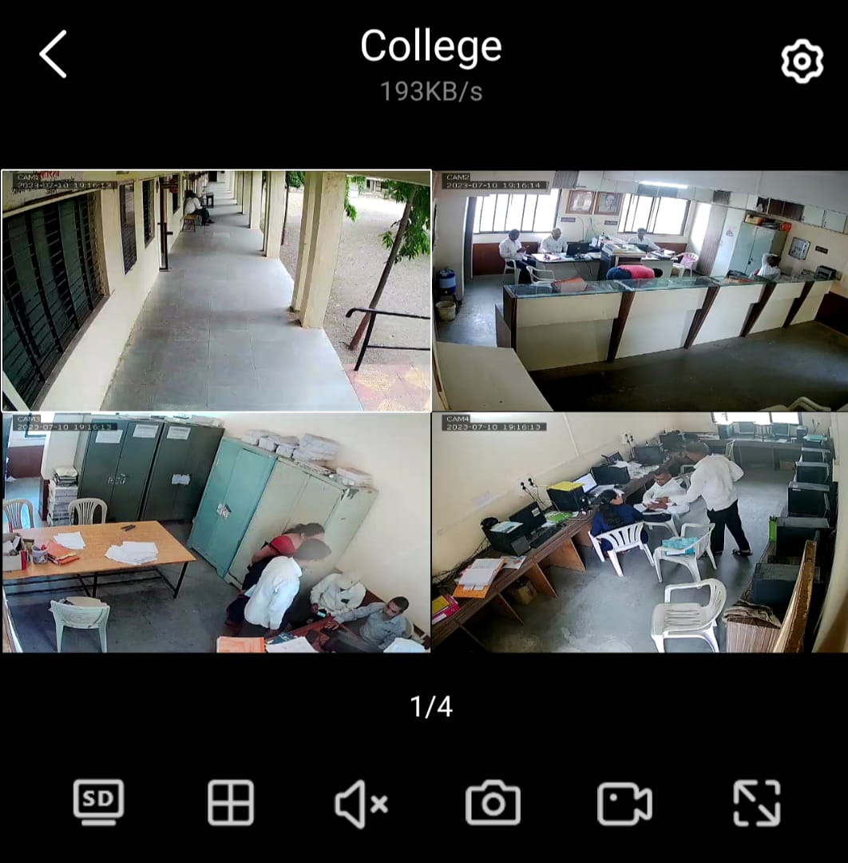

**MAHADBT SCHOLERSHIP**

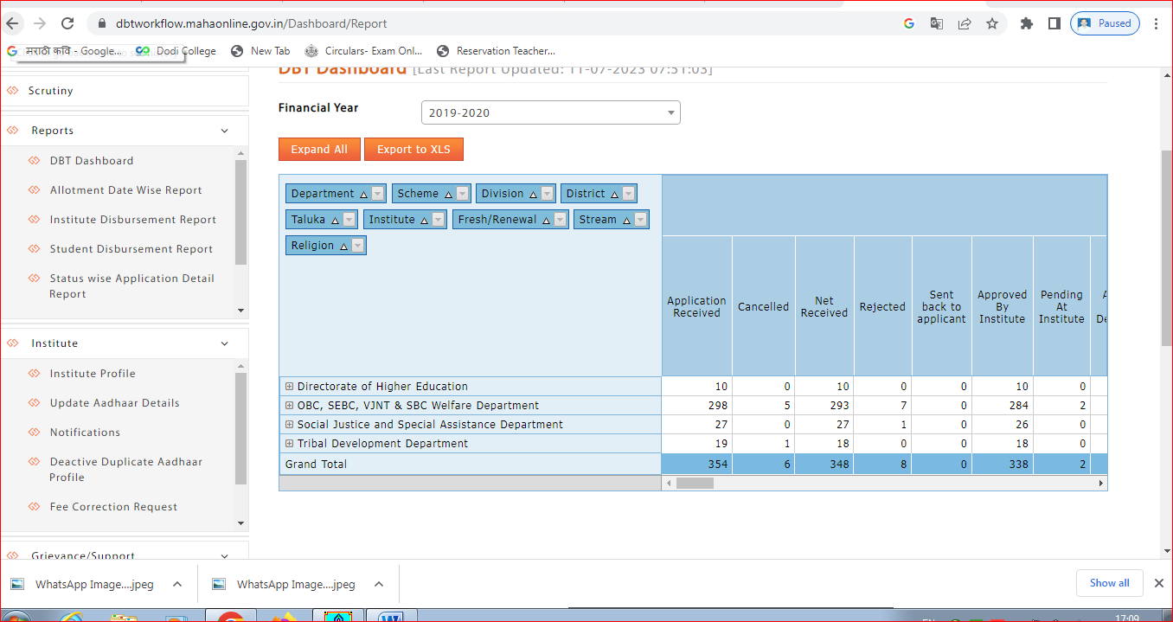

**Management Information System of Higher Educational Institution**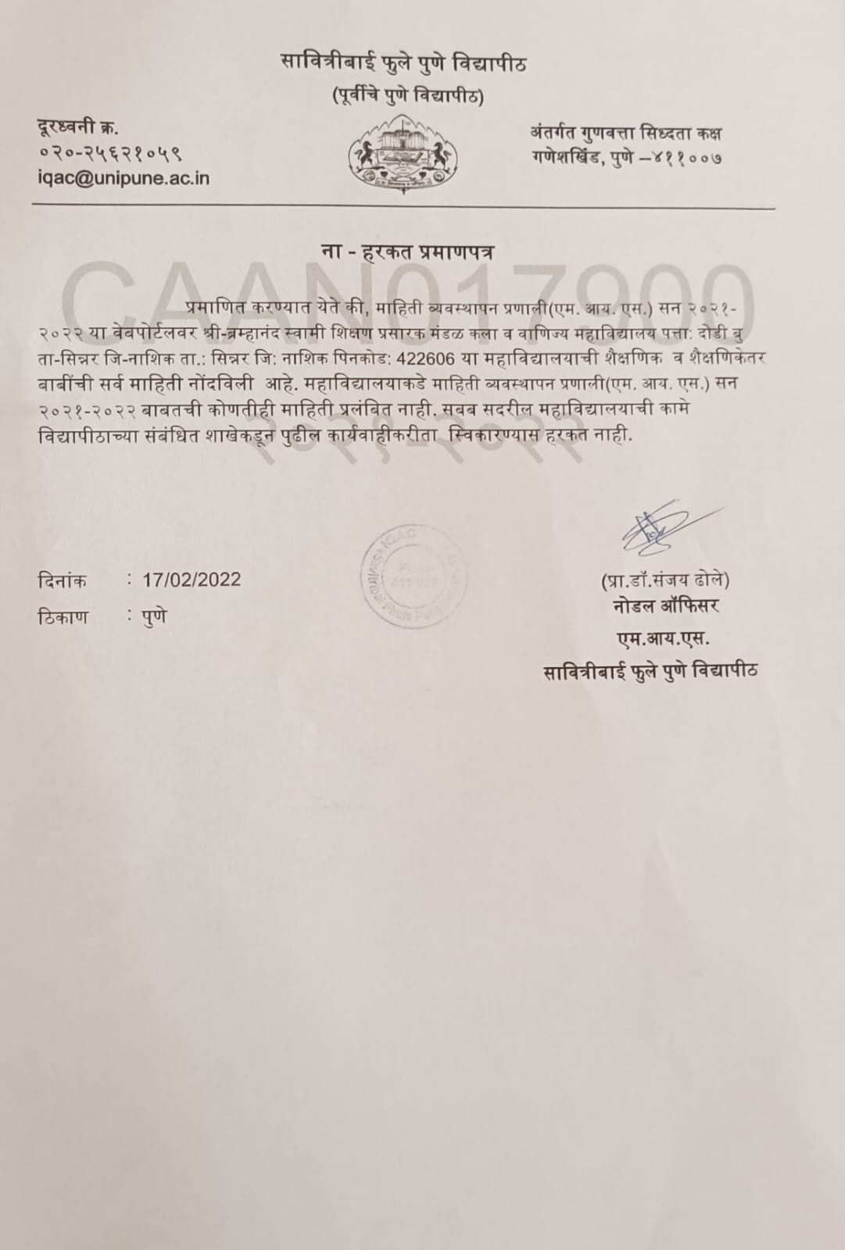

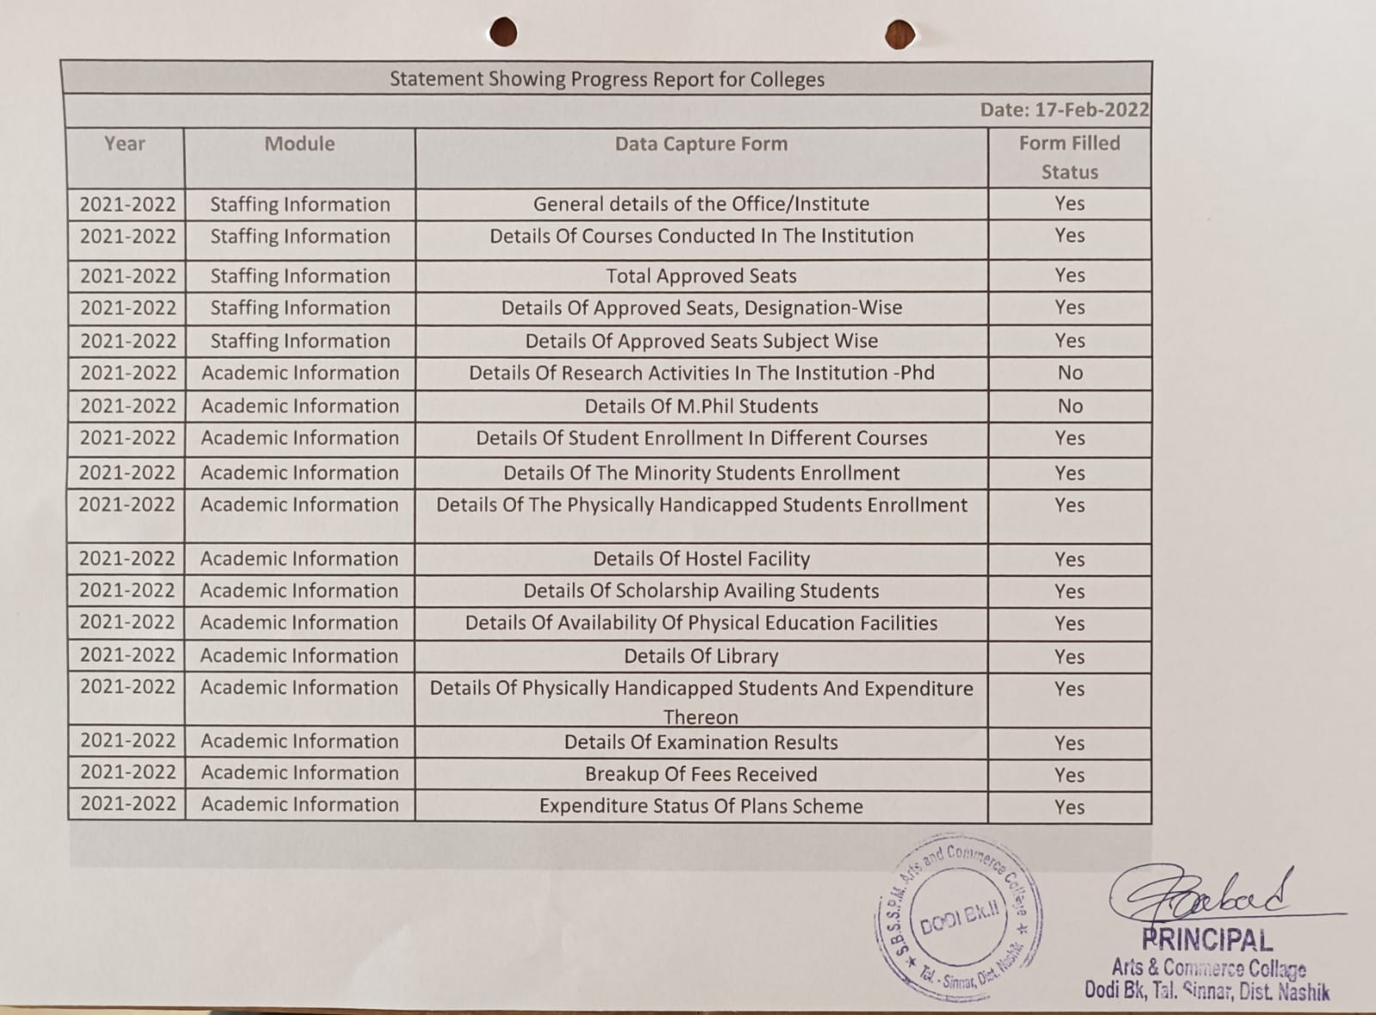

**FINANCE AND ACCOUNTS**

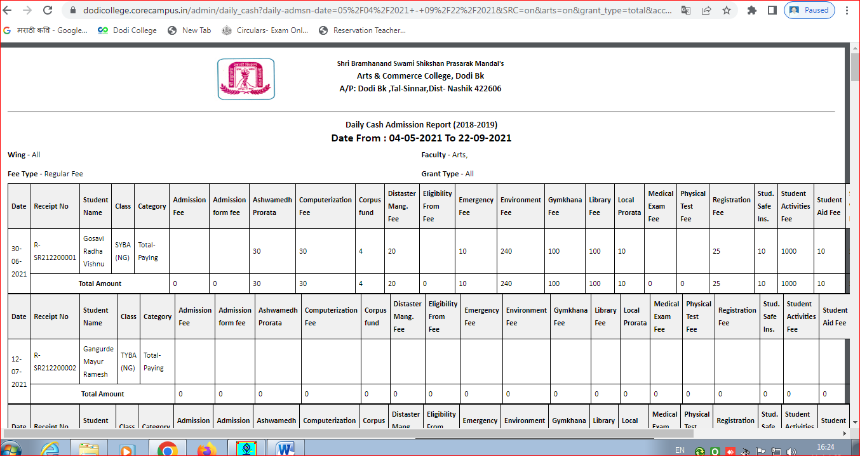

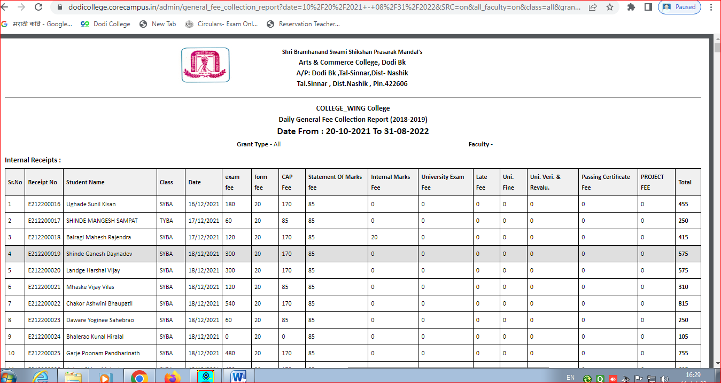

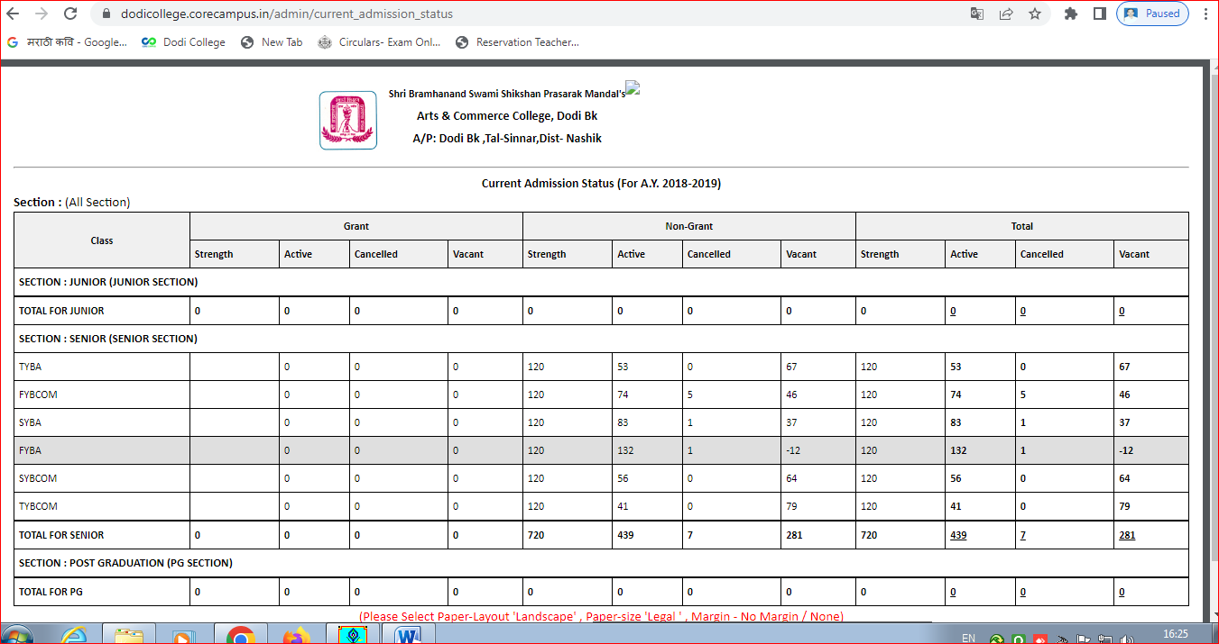

**ADMISSION SOFTWARE**

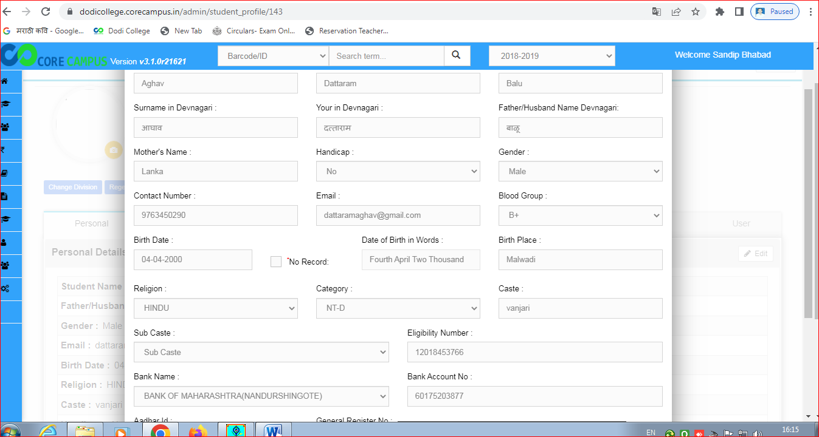

**EXAM PORTAL**

